Conjugate Angles
# Source: AI Source: Provided by: [Data Path: Persons Table -> ID Column: 1, Name_En Column: Motasem Essam] -> From: [ChatGPT] on [7/25/2026]
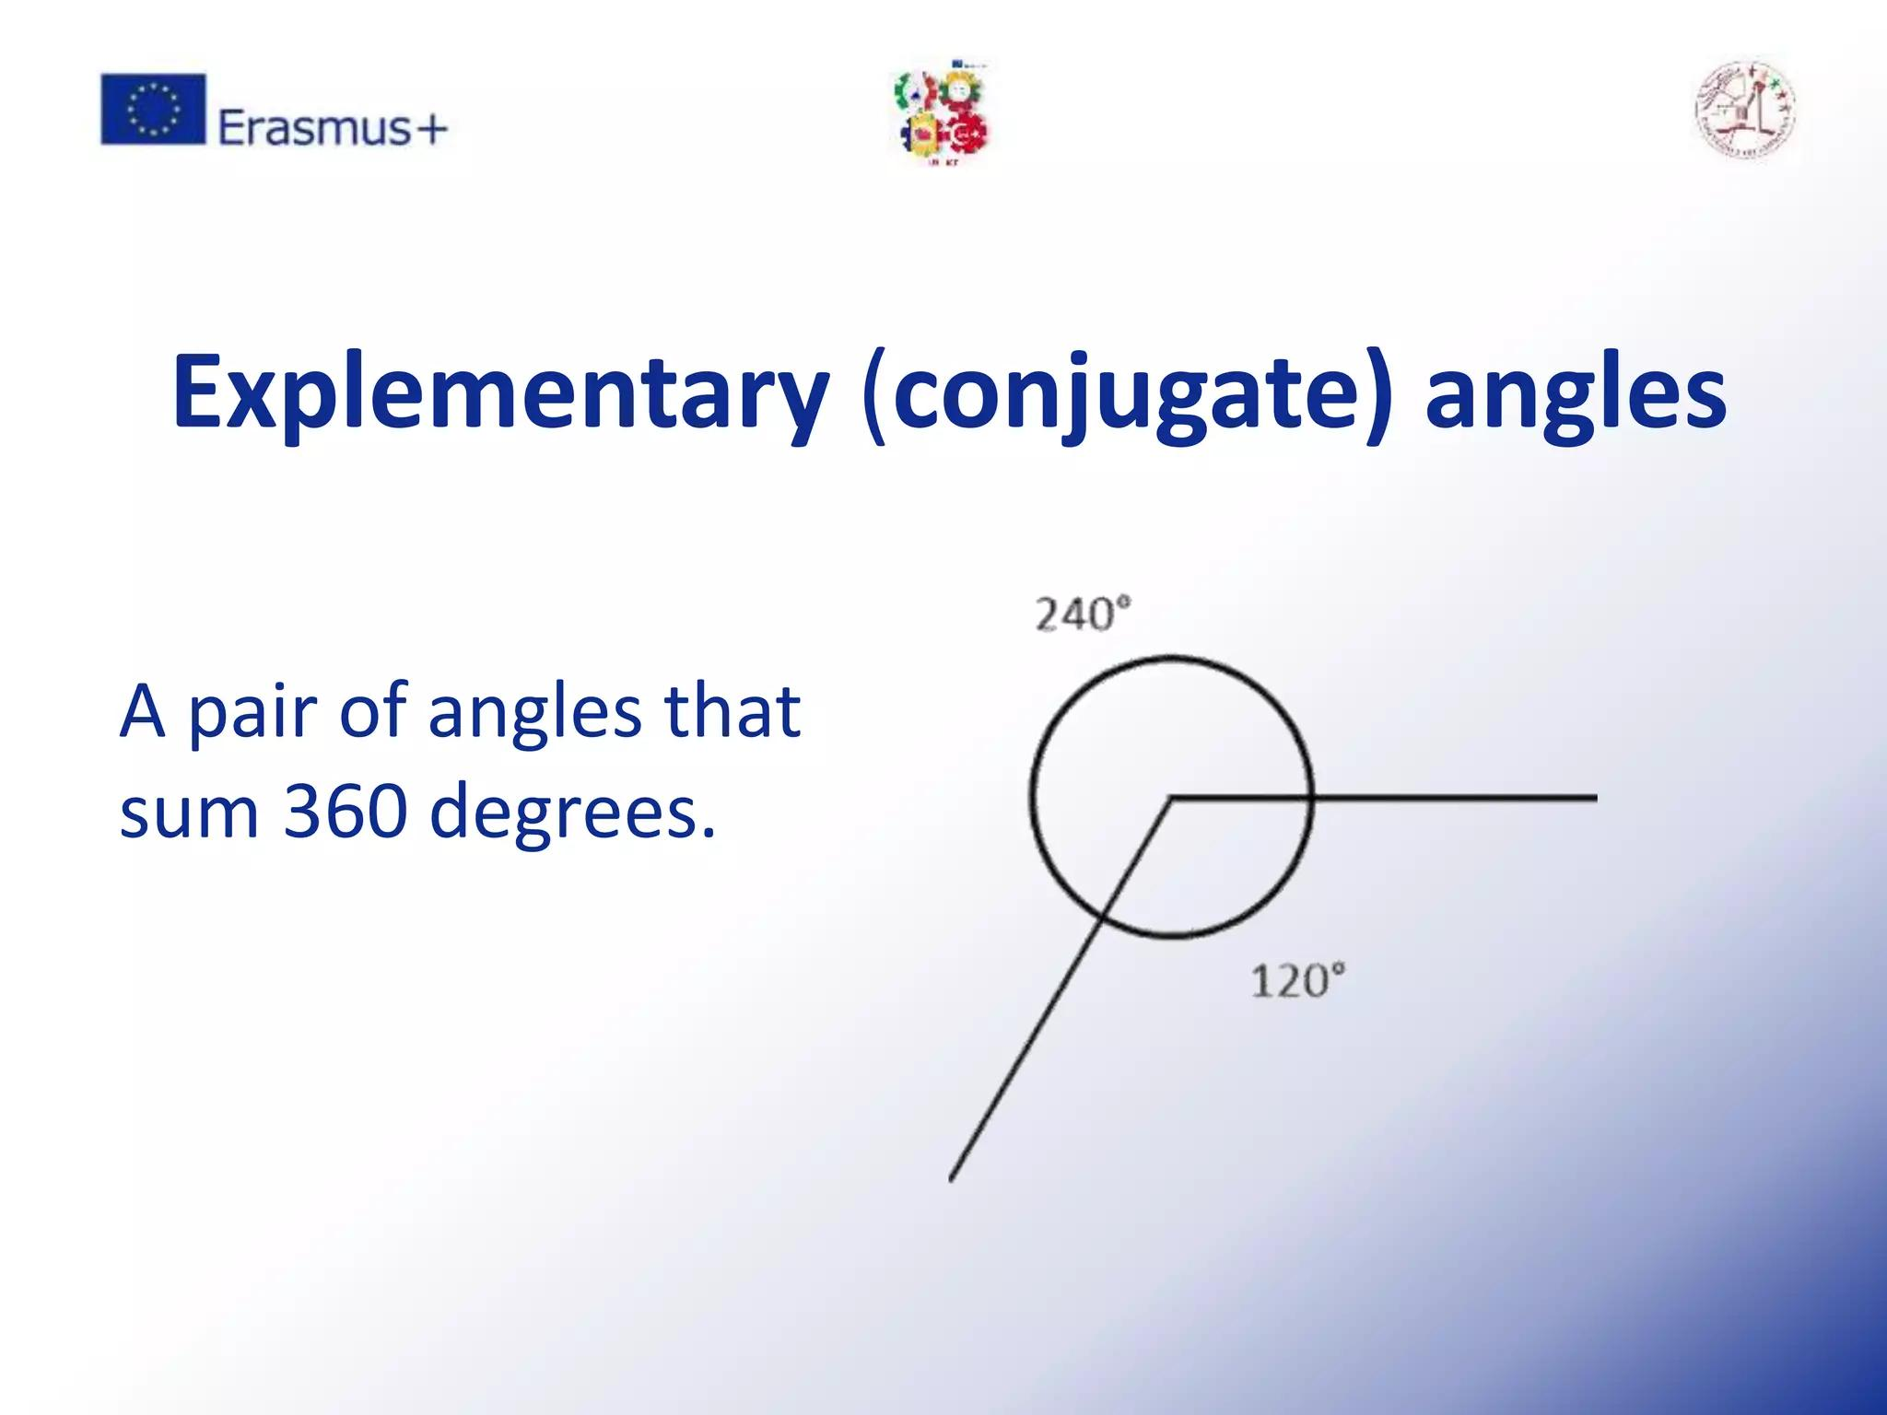
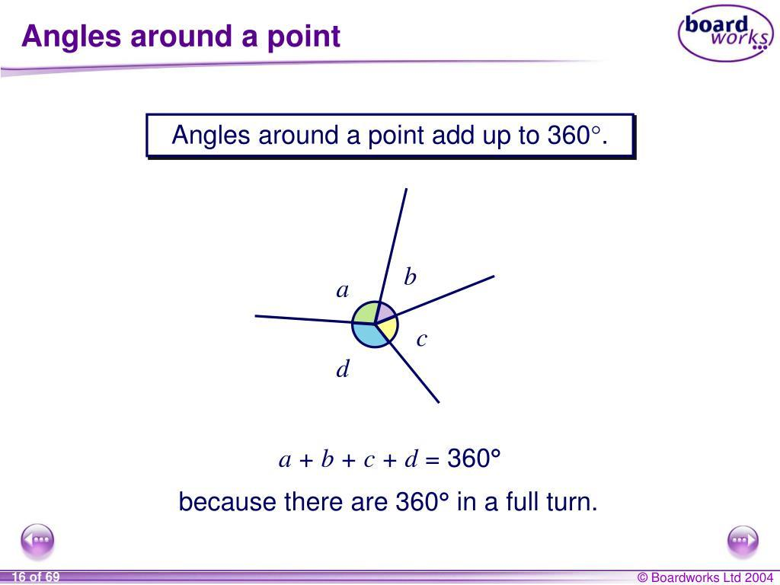
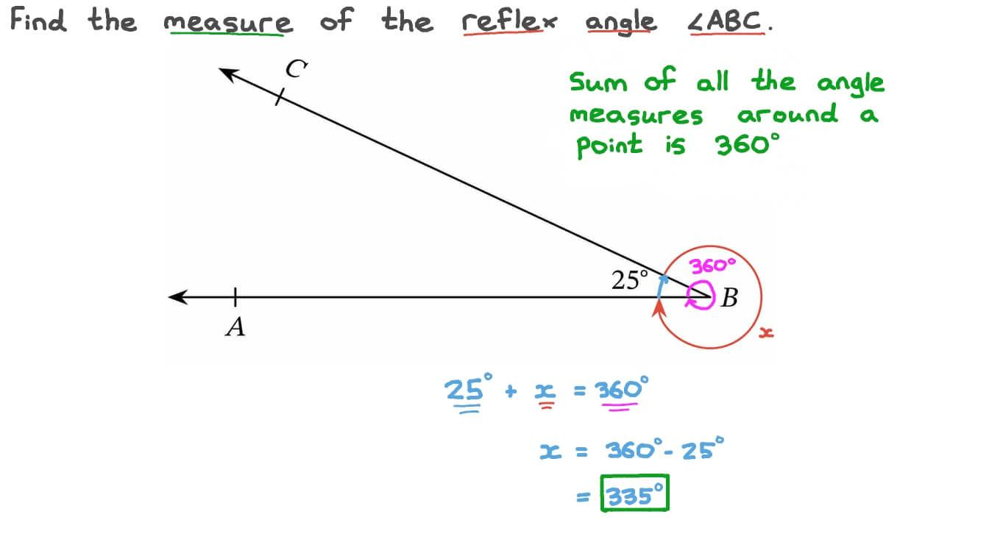
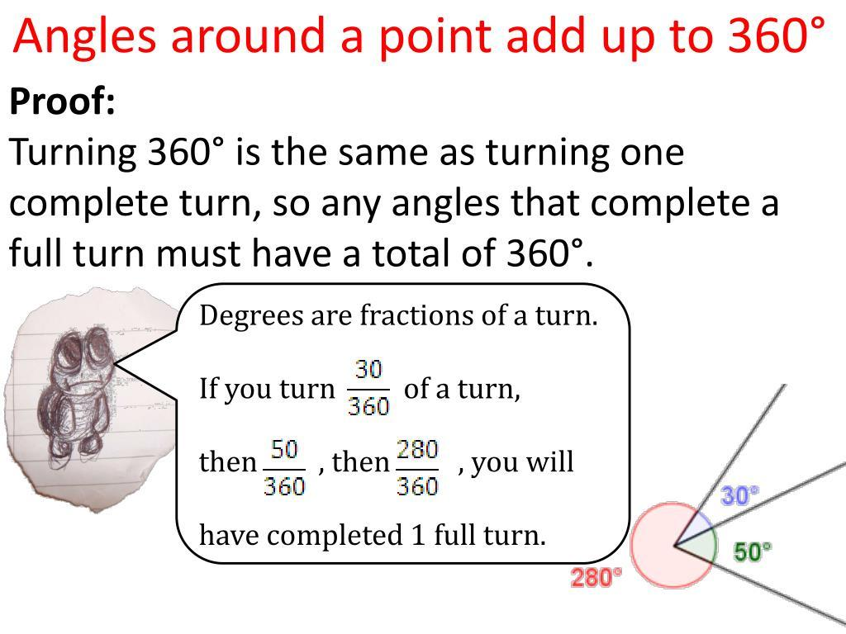

Definition
# Source: AI Source: Provided by: [Data Path: Persons Table -> ID Column: 1, Name_En Column: Motasem Essam] -> From: [ChatGPT] on [7/25/2026]
Conjugate Angles (also called Explementary Angles) are two angles whose measures add up to exactly (360^\circ).
They may be adjacent or non-adjacent. When combined, they represent one complete angle (full rotation).
The relationship is defined as:
$$m∠A+m∠B={360}^{∘}$$

Characteristics
# Source: AI Source: Provided by: [Data Path: Persons Table -> ID Column: 1, Name_En Column: Motasem Essam] -> From: [ChatGPT] on [7/25/2026]
Conjugate angles:
- Have a total measure of:
$${360}^{∘}$$
- Can be adjacent or non-adjacent.
- Do not have to be equal.
- May consist of any angle types whose sum is ${360}^{∘}$.
- Together represent one complete revolution.

Illustration

Adjacent Conjugate Angles
# Source: AI Source: Provided by: [Data Path: Persons Table -> ID Column: 1, Name_En Column: Motasem Essam] -> From: [ChatGPT] on [7/25/2026]
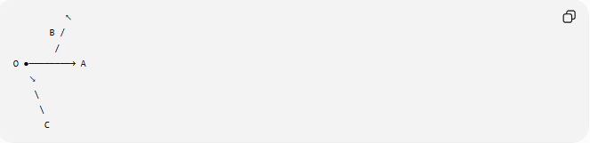
↖
B /
/
O ●────────→ A
↘
\
\
C
The two adjacent angles around vertex $O$ together make a full turn.
Example:
$${120}^{∘}+{240}^{∘}={360}^{∘}$$

Non-Adjacent Conjugate Angles
# Source: AI Source: Provided by: [Data Path: Persons Table -> ID Column: 1, Name_En Column: Motasem Essam] -> From: [ChatGPT] on [7/25/2026]
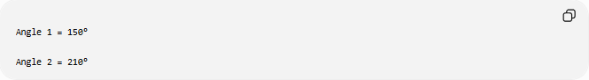
Angle 1 = 150°

Angle 2 = 210°
Although separate, they are conjugate because:
$${150}^{∘}+{210}^{∘}={360}^{∘}$$

Mathematical Representation
# Source: AI Source: Provided by: [Data Path: Persons Table -> ID Column: 1, Name_En Column: Motasem Essam] -> From: [ChatGPT] on [7/25/2026]
If two angles are
$$∠A$$
and
$$∠B$$
then they are conjugate if
$$m∠A+m∠B={360}^{∘}$$
In radians:
$$θ_{1}+θ_{2}=2π$$

Examples
# Source: AI Source: Provided by: [Data Path: Persons Table -> ID Column: 1, Name_En Column: Motasem Essam] -> From: [ChatGPT] on [7/25/2026]
Example 1
Given
$$∠A={75}^{∘}$$
Its conjugate angle is
$${360}^{∘}-{75}^{∘}={285}^{∘}$$

Example 2
Given
$$∠A={225}^{∘}$$
Its conjugate angle is
$${360}^{∘}-{225}^{∘}={135}^{∘}$$

Common Conjugate Angle Pairs
# Source: AI Source: Provided by: [Data Path: Persons Table -> ID Column: 1, Name_En Column: Motasem Essam] -> From: [ChatGPT] on [7/25/2026]
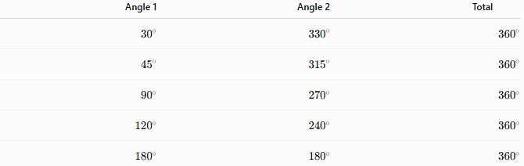
Angle 1 | Angle 2 | Total
$${30}^{∘}$$ | $${330}^{∘}$$ | $${360}^{∘}$$
$${45}^{∘}$$ | $${315}^{∘}$$ | $${360}^{∘}$$
$${90}^{∘}$$ | $${270}^{∘}$$ | $${360}^{∘}$$
$${120}^{∘}$$ | $${240}^{∘}$$ | $${360}^{∘}$$
$${180}^{∘}$$ | $${180}^{∘}$$ | $${360}^{∘}$$

Properties of Conjugate Angles
# Source: AI Source: Provided by: [Data Path: Persons Table -> ID Column: 1, Name_En Column: Motasem Essam] -> From: [ChatGPT] on [7/25/2026]
1. Sum Property
The defining property is:
$$θ_{1}+θ_{2}={360}^{∘}$$

2. Conjugate of an Angle
For an angle
$$θ$$
its conjugate is
$${360}^{∘}-θ$$

3. Relationship with a Complete Angle
When two conjugate angles are combined, they form a complete angle:
$${360}^{∘}$$

4. Equal Conjugate Angles
If two conjugate angles are equal:
$$θ+θ={360}^{∘}$$
then
$$2θ={360}^{∘}$$
$$θ={180}^{∘}$$
Thus, two equal conjugate angles are both straight angles.

Real-World Examples
# Source: AI Source: Provided by: [Data Path: Persons Table -> ID Column: 1, Name_En Column: Motasem Essam] -> From: [ChatGPT] on [7/25/2026]
Conjugate angles appear in:
- A wheel completing one full revolution.
- A clock hand making one complete turn.
- Robotic joints capable of full rotation.
- Rotating gears.
- Circular navigation systems.

Applications
# Source: AI Source: Provided by: [Data Path: Persons Table -> ID Column: 1, Name_En Column: Motasem Essam] -> From: [ChatGPT] on [7/25/2026]
Conjugate angles are used in:
- Plane Geometry
- Coordinate Geometry
- Trigonometry
- Circular Motion
- Engineering
- Robotics
- CAD (Computer-Aided Design)
- Computer Graphics
- Physics

Advantages
# Source: AI Source: Provided by: [Data Path: Persons Table -> ID Column: 1, Name_En Column: Motasem Essam] -> From: [ChatGPT] on [7/25/2026]
Studying conjugate angles helps to:
- Understand complete rotations.
- Solve circular geometry problems.
- Analyze rotational motion.
- Work with polar coordinates.
- Model cyclic systems.

Limitations
# Source: AI Source: Provided by: [Data Path: Persons Table -> ID Column: 1, Name_En Column: Motasem Essam] -> From: [ChatGPT] on [7/25/2026]
Conjugate angles:
- Must add exactly:
$${360}^{∘}$$
- Are different from complementary and supplementary angles.
- Are less commonly discussed in elementary geometry than complementary or supplementary angles.

Comparison with Other Angle Relationships
# Source: AI Source: Provided by: [Data Path: Persons Table -> ID Column: 1, Name_En Column: Motasem Essam] -> From: [ChatGPT] on [7/25/2026]
Relationship | Condition
Complementary Angles | Sum $={90}^{∘}$
Supplementary Angles | Sum $={180}^{∘}$
Conjugate (Explementary) Angles | Sum $={360}^{∘}$
Adjacent Angles | Share a common vertex and side
Vertical Angles | Opposite angles formed by intersecting lines

Key Points
# Source: AI Source: Provided by: [Data Path: Persons Table -> ID Column: 1, Name_En Column: Motasem Essam] -> From: [ChatGPT] on [7/25/2026]
- Conjugate Angles are two angles whose measures sum to:
$${360}^{∘}$$
- Formula:
$$m∠A+m∠B={360}^{∘}$$
- In radians:
$$θ_{1}+θ_{2}=2π$$
- The conjugate of an angle is:
$${360}^{∘}-θ$$
- They represent one complete rotation.

Conclusion
# Source: AI Source: Provided by: [Data Path: Persons Table -> ID Column: 1, Name_En Column: Motasem Essam] -> From: [ChatGPT] on [7/25/2026]
Conjugate Angles, also known as Explementary Angles, are pairs of angles whose measures add up to exactly ${360}^{∘}$, representing a complete revolution around a common point. They are important in the study of rotations, circular motion, and angular relationships, especially in plane geometry, coordinate geometry, trigonometry, engineering, robotics, CAD, physics, and computer graphics, where full-turn measurements and cyclic motion are frequently analyzed.

